Reference 1

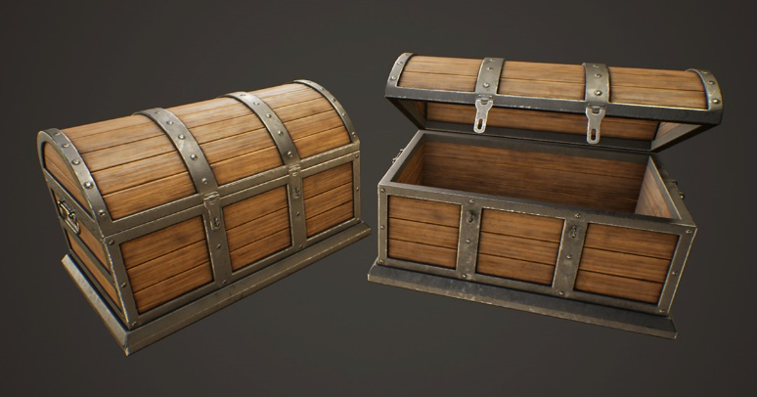

<https://www.google.com/url?sa=i&url=https%3A%2F%2Fassetstore.unity.com%2Fpackages%2F3d%2Fprops%2Fmedieval-treasure-chest-wooden-chest-x-206790&psig=AOvVaw2-bUeNT2pyIVFs4GZYgiyh&ust=1651553523560000&source=images&cd=vfe&ved=2ahUKEwjUooi6gsD3AhWUQGwGHVglBUcQjRx6BAgAEAs>

Reference 2

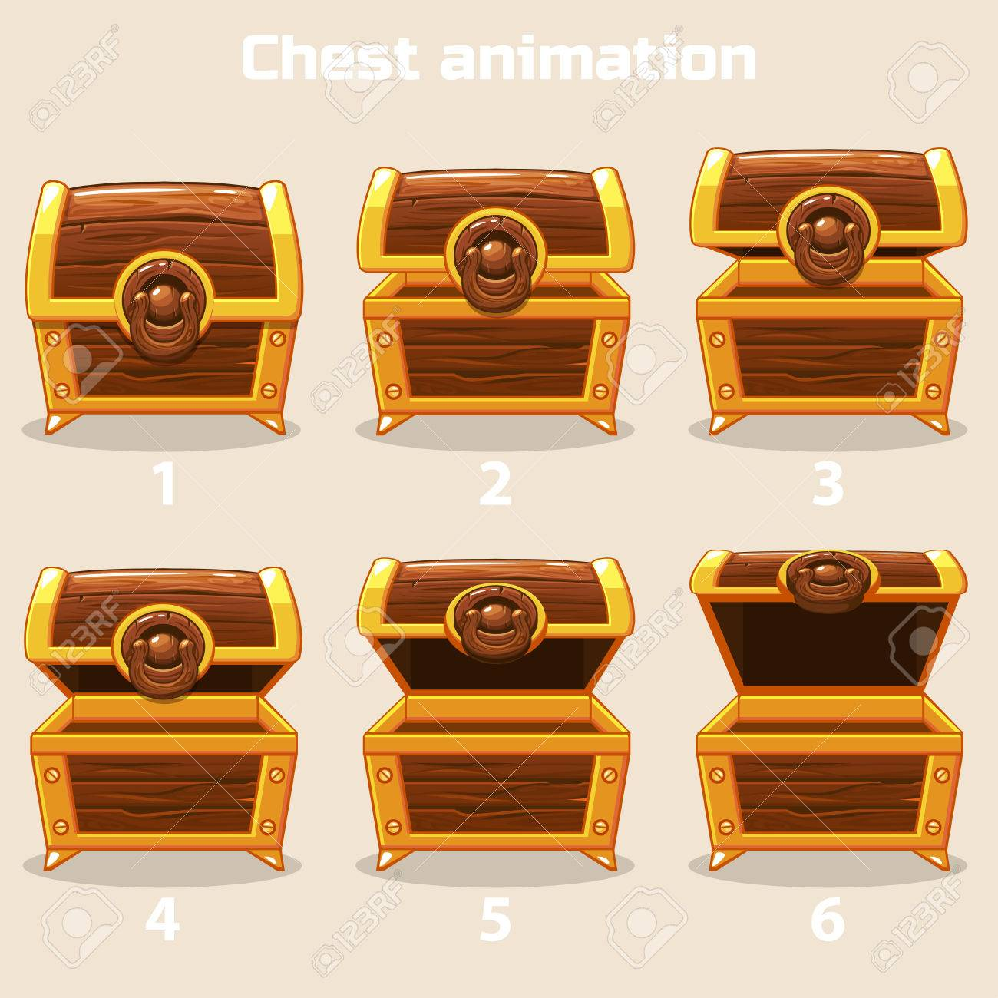

<https://www.google.com/url?sa=i&url=https%3A%2F%2Fwww.123rf.com%2Fphoto_78353225_animation-antique-old-box-step-by-step-open-and-closed-wooden-treasure-chest.html&psig=AOvVaw2fhkcg6sEpn4Z09W5w7Wc8&ust=1651553550736000&source=images&cd=vfe&ved=2ahUKEwi3-ILHgsD3AhVIYmwGHev4C3YQjRx6BAgAEAs>

Reference 3

<https://youtu.be/aH4pnvOFyN0>